**Connecticut: Drugs, Death, and the Data**

David Hinton, Shivani Sampathkumar, Allison Gallant

**Abstract**

A study of Connecticut counties between 2012 and 2016 investigates how accidental drug-related death rates have changed and explores any trends between the number of opioid related deaths and factors such as opioid-related treatment admissions, government housing assistance, and what specific drug was found in the system at the time of death. Linear regression and clustering was applied to our data sets to reveal the relationships between the variables we explored. Our research found that reactive strategies to opioid abuse, such as treatment facilities, do not significantly lower the number of deaths in those communities. There were greater number of deaths in counties that had large treatment facilities and in low-income counties. We have predicted that preventative measures may be more likely to reduce the total number of opioid-related deaths.

**Introduction**

In recent years, America has been suffering from what has been coined an ‘opioid crisis’ or ‘opioid epidemic’. In the 1980’s, published articles were released claiming that opioids were non-addictive pain therapy choices and the medical community soon saw a significant increase in the rate of opioid prescriptions written.1 Since then, it has been proven that this drug class is indeed highly addictive with potential for abuse. Despite this new information, opioid overdoses continue to rise and, in 2016, accounted for more than 42,000 deaths in the United States, more than any other year previously on record, with 40% of those deaths involving a prescription opioid.2 There are numerous strategies and programs that have been implemented, both at federal and state levels, in response to this growing issue. In addition, The National Institutes of Health has launched initiatives in three research areas to address the opioid crisis including overdose reversal, addiction treatment and pain management.3

This study focuses on exploring factors that might influence the rates of opioid overdoses in Connecticut counties between the years 2012 and 2016 in order to gain insight into which programs are showing success and where others are lacking. We begin by examining the significant increase in opioid overdoses in Connecticut counties during this time period and gather insight into the population experiencing these overdoses. Next, we look for relationships between counties with increasing rates of overdoses and factors such as admittance to opioid-treatment facilities and access to government housing assistance within these counties. We explore whether, over time, the number of treatment admissions in a county may have played a role in reducing the number of overdoses that it experienced. We also explore how government housing assistance in counties, often received by low-income families, senior citizens, and the disabled, has changed over this time period and look for a relationship between this factor and the changes in overdoses per county.4 We then investigate if there has been a change in the most commonly used drugs during this time period and whether that could be linked to changes in legislation. We conclude our study with an analysis of our findings and our predictions for the future regarding the opioid crisis.

**Methodology**

The group of interest in this study are those factors resulting in an opioid-related death. The Primary dataset that was available to this study are from the Office of the Chief Medical Examiner which includes the toxicity report, death certificate, as well as a scene investigation, described as Accidental Drug Related Deaths. The next data source was provided through secondary research by the Department of Mental Health and Addiction Services, which includes Town level data on depicting the number of entries, and individuals served per year in treatment programs, described as Opioid-Related Treatment Admissions. The final data source was provided through secondary research by the Department of Housing, which includes counts of assisted housing units or housing receiving financial assistance under any governmental program, described as Affordable Housing By Town.

The data analytic tools used in this study consist of Numpy, Pandas, Matplotlib, sklearn, basemap and geoPandas. These are popular libraries used to prepare and interpret a dataset for statistical analysis. All three datasets share a common attribute of Town location, which was used later to join each set. However, before they were able to be merged, these datasets attribute needed to be checked for null values, mapped string values to binary or matrices, and normal distribution. Once all cleaning techniques were completed, we applied a grouping method that took the average numerical value of each attribute [Admissions, DRUG, Total Assisted Units] over the course of 2012 to 2016.

After processing of the data was complete, we were able to apply the linear regression model. The first step was to split our dataset into a training and testing set. We were able to apply the linear regression formula to our training set which gave us our coefficient for Total Assisted Units (0.9355) and Admissions (0.7938). The intercept for our model is (0.004821). Using the statistical method R-squared, we were able to see the accuracy of the regression model. The resulting model for Total assisted units, 64% of the variability in the independent variable, can be explained using the dependent variable.

Finally, clustering was implemented to gain further insight into the data. The K-means was initialized to three and the labels of the resulting cluster were joined to the data set. The clustering revealed a relationship among Towns receiving a more considerable amount of Government assistant and Opioid-related admissions to anticipate a higher likelihood of deaths related to Fentanyl abuse.

**Results**

The demographics of the population dying from opioid overdose were primarily in the 30-55 age group (Figure 1). 80% of the population we are studying were white (Figure 2) and mostly male (Figure 3). The location of these overdoses were in the areas surrounding the major cities in Connecticut, especially Hartford, Waterbury, New Haven and Norwalk (Figure 4). The analysis of drugs found in system at the time of death showed trends regarding change in drugs used over time; there has been The past three years showed a tremendous increase in fentanyl-related deaths (Figure 5).

Due to the social impact of fentanyl abuse in recent years, our analysis looked at predictor variables for fentanyl deaths, such as access to treatment, as measured by the number of treatment admissions, and government housing assistance which is a measure of financial need. In the Access to Treatment vs Fentanyl Deaths graph (Figure 6), there is a relationship between the number of admissions and the number of fentanyl deaths in a county, with approximately 100 admissions correlating with 80 deaths. In the Government Housing Assistance vs Fentanyl Deaths graph (Figure 7), there is a positive relationship between the number of assisted units and the number of fentanyl deaths, indicating that fentanyl deaths may be more common in low income areas.

While assessing the relationship between government assistance, treatment admissions and fentanyl deaths in a cluster model (Figure 8), cluster 1 represents largest cities in Connecticut, cluster 2 represents large towns and cluster 3 represents outliers. In cluster 1, there are more government assistance and treatment admissions and slightly less fentanyl deaths than in cluster 2, which has relatively no government assistance or treatment admissions. The slight difference in fentanyl deaths between cluster 1 and cluster 2, despite a large difference in the access to treatment between the two clusters, signifies that access to treatment reduces fentanyl deaths by an insignificant amount. Overall, our results signify that increased access to treatment may not be the strongest approach to reducing fentanyl-related deaths.

[All figures can be found in Appendix A]

**Discussion**

In today’s opioid crisis, it seems that reactive actions to opioid abuse, like access to treatment, only play a small role in overcoming addiction or death. This can be seen in our results as cities in Connecticut with greater treatment access still have large numbers of opioid-related death. Furthermore, there seems to be very little difference in number of deaths between areas with greater access to treatment and areas with relatively no access to treatment. Looking forward, it may be necessary to consider alternative approaches to combating the opioid crisis.

The results of our data show that there may need to be stronger preventative actions taken to reduce opioid abuse. One of these preventative actions may include stricter prescribing of opioids that limit the writing of long-term opioid prescriptions and shifting prescribing to less addictive painkillers such as over-the-counter alternatives like ibuprofen and naproxen. Another action could be community-based interventions, such as educational programs and enforcing safe drug disposal. According to the article “Preventative Measures: Community-Based Prevention and Strategies for the Opioid Crisis”, current community-level interventions include public education of naloxone use, clinician-patient partnership to assess risk factors for opioid misuse, and community based medication disposal programs.6 However, creating effective preventative measures still remains one of the challenges of the current crisis.

Another strategy to addressing the opioid abuse issue in this country is the research and development of less addictive opioid medications. Recently, there have been several pharmaceutical and biotechnology companies trying to address this issue. For example, Nektar Therapeutics created a non-addictive mu-receptor agonist opioid, which does not pass the blood brain barrier, thereby producing less addictive pain relief. This drug is currently in Phase 3 and is expected to enter the market in 2018. Alternatively, policies surrounding the use of medical marijuana for pain relief have been changing over recent years. According to the article “Legalization of Medical Marijuana and Incidence of Opioid Mortality”, the 13 states which approved medical marijuana, had a decline in opioid-related mortality which strengthened over time, with a mean decline of 24.8%.7 This shows that there is evidence supporting change in prescribing habits for chronic pain relief.

Overall, there needs to be an increase in preventative changes to reduce opioid-related death, rather than primarily focusing on reactive treatment options. Further studies should address the efficacy of preventative actions on opioid-related deaths.

**Appendix A**

**Figure 1. Age versus Overdose Deaths**

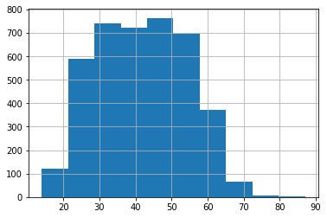

**Figure 1:** This graph shows that deaths due to overdose are concentrated in the 30-55 age group and slightly less in 20-30 or 60-70 age groups

**Figure 2.**  **Number of Overdose Deaths by Gender**

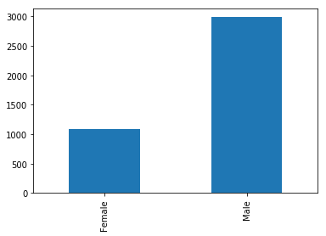

**Figure 2.** This graph shows the breakdown of overdose deaths by gender; males account for nearly three times the amount of deaths related to opioid overdose.

**Figure 3. Overdose Deaths by Population Race**

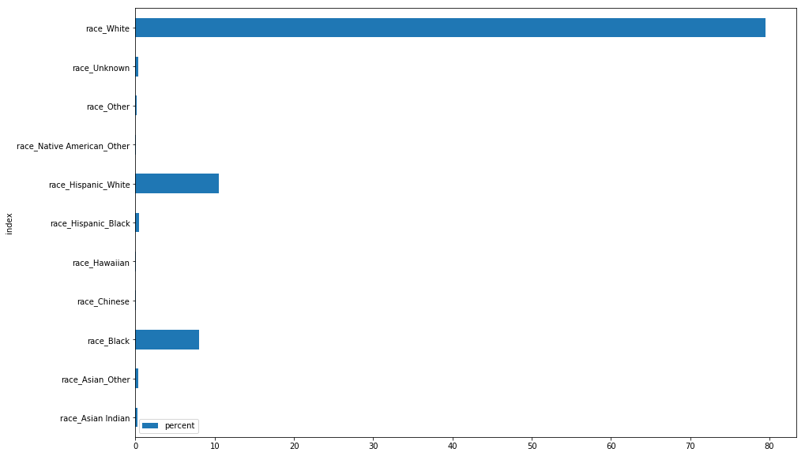

**Figure 3.** This graph shows the breakdown of overdose deaths by race. The majority of overdose deaths are of white race.

**Figure 4: Map of Opioid-Related Deaths in Connecticut between 2012 and 2017**

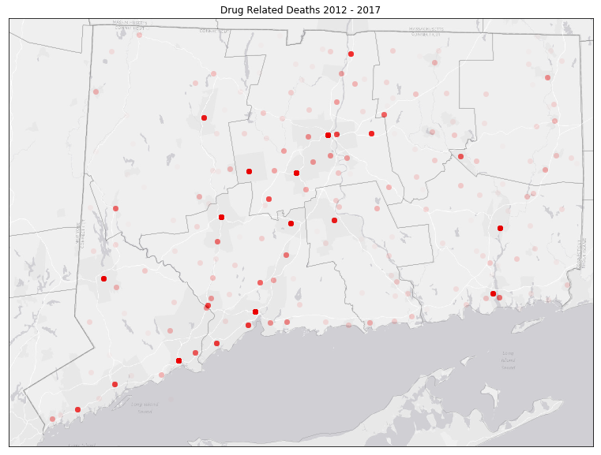

**Figure 4.** This graph shows the location of overdose deaths in Connecticut. The locations follow the areas surrounding major cities such as New Haven and Hartford.

**Figure 5. Drug Found in System Between 2012-2017**

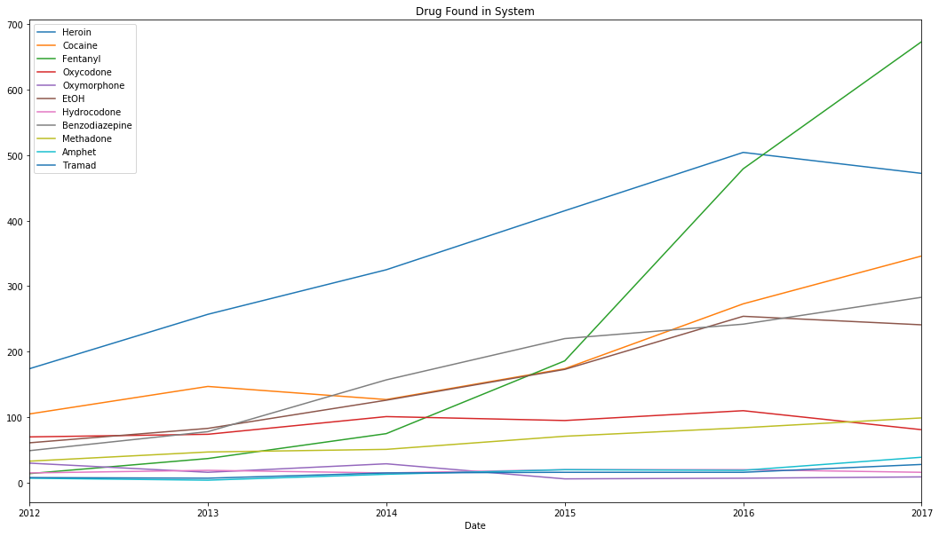

**Figure 5.** This graph shows the trends in drugs found in people’s systems at the time of death from overdose. Over the recent years, there has been a tremendous increase in overdose death from fentanyl (shown in green).

**Figure 6. Access to Treatment versus Fentanyl Overdose Deaths per County**

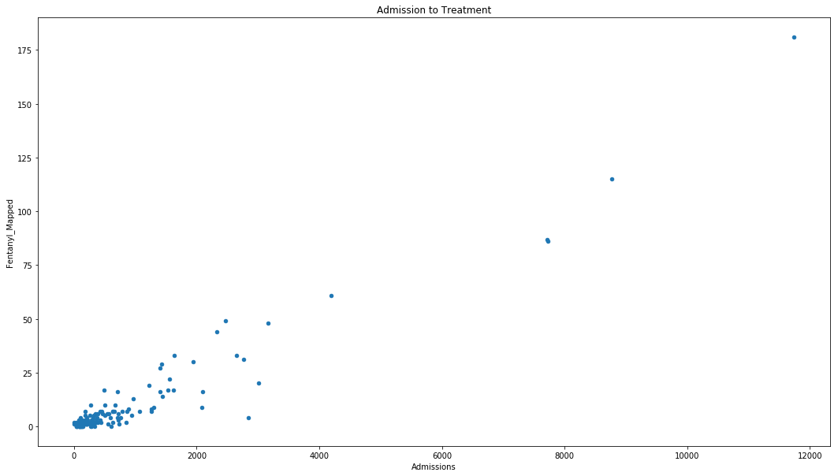

**Figure 6.** This graph shows the increase in fentanyl death associated with increase in treatment admission.

**Figure 7. Government Assistance versus Fentanyl Overdose Deaths per Count**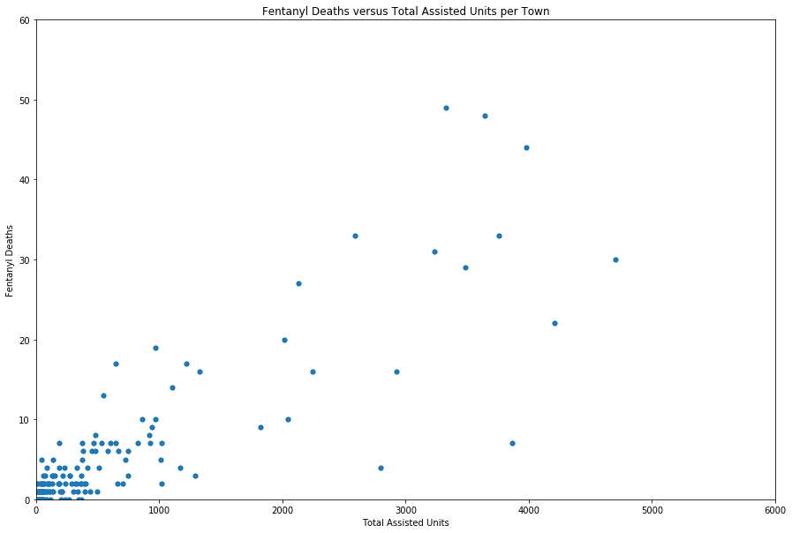

**Figure 7.** There is an increase in fentanyl overdose in areas with greater government assistance with housing, indicating that fentanyl use is more prevalent in low-income populations.

**Figure 8: Cluster Model of Connecticut Towns based on Government Housing Assistance, Treatment Admissions and Fentanyl-related Deaths**

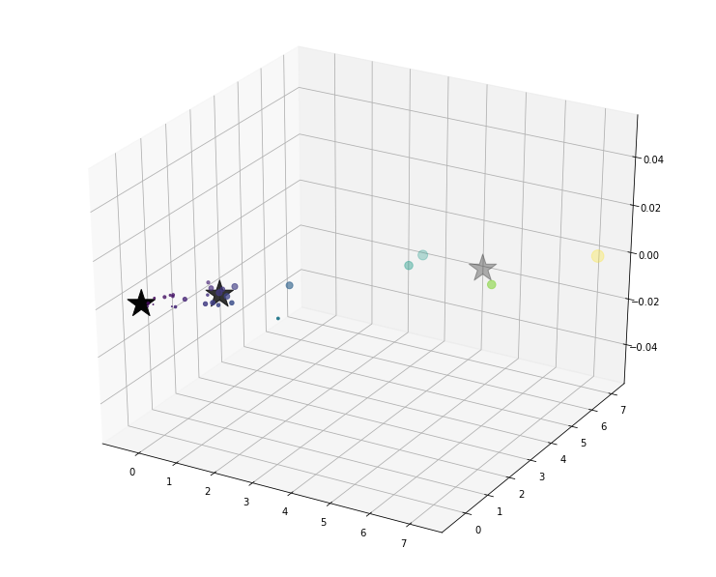

**Figure 8.** This cluster model shows three different groups of cities based on government housing assistance, treatment admissions and fentanyl deaths. In cluster 1 (rightmost), there is a large number of treatment admissions, in comparison to cluster 2 (leftmost). However, the two clusters have a negligible difference in the number of deaths, indicating that access to treatment may not be the strongest approach in preventing fentanyl deaths.

**Team Member Contribution**

David Hinton: primary coder due to his IS background and skills, methodology section.

Allison Gallant: researched background information and policies surrounding opioid drug use, organized documents, abstract and introduction section.

Shivani Sampathkumar: completed an analysis of the results, researched community interventions and alternative prescribing options for chronic pain, results section, discussion section.

**References**

1. HHS Office, and Public Affairs. “About the U.S. Opioid Epidemic.” *HHS.gov*, US Department of Health and Human Services, 6 Mar. 2018, www.hhs.gov/opioids/about-the-epidemic/.
2. “Opioid Overdose.” *Centers for Disease Control and Prevention*, Centers for Disease Control and Prevention, 23 Oct. 2017, www.cdc.gov/drugoverdose/.
3. Volkow, Nora, and Francis Collins. “‘All Scientific Hands on Deck’ to End the Opioid Crisis.”*Advancing Addiction Science*, National Institute on Drug Abuse , 31 May 2017, www.drugabuse.gov/about-nida/noras-blog/2017/05/all-scientific-hands-deck-to-end-opioid-crisis.
4. “Rental Assistance.” *U.S. Department of Housing and Urban Development (HUD)*, [www.hud.gov/topics/rental_assistance](http://www.hud.gov/topics/rental_assistance).
5. <https://data.ct.gov/Housing-and-Development/Affordable-Housing-by-Town-2011-Present/3udy-56vi/data>
6. Koh HK. Community-Based Prevention and Strategies for the Opioid Crisis. *JAMA*. 2017;318(11):993–994. doi:10.1001/jama.2017.13767
7. Hayes MJ, Brown MS. Legalization of Medical Marijuana and Incidence of Opioid Mortality. *JAMA Intern Med*. 2014;174(10):1673–1674. doi:10.1001/jamainternmed.2014.2716